**INDEX.htm**

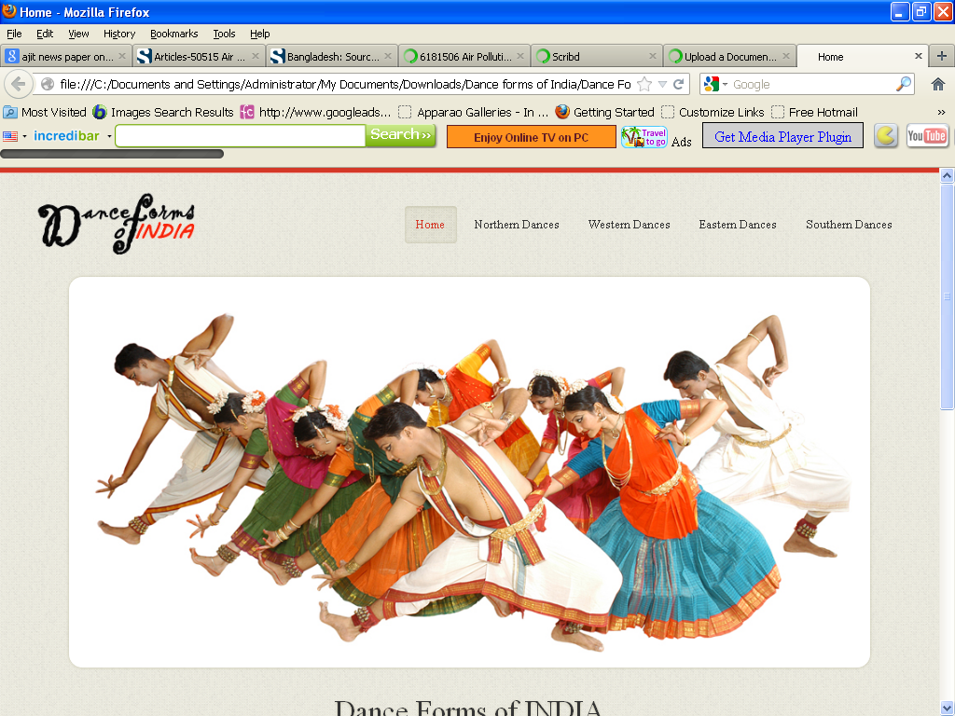

<!DOCTYPE html>

<html lang="en">

<head>

<title>Home</title>

<meta charset="utf-8">

<!--css-->

<link rel="stylesheet" href="css/reset.css" type="text/css" media="screen">

<link rel="stylesheet" href="css/style.css" type="text/css" media="screen">

<link rel="stylesheet" href="css/grid.css" type="text/css" media="screen">

<link rel="icon" href="images/favicon.ico" type="image/x-icon">

<link rel="shortcut icon" href="images/favicon.ico" type="image/x-icon" />

<link rel="stylesheet" href="css/flexslider.css" type="text/css" media="screen">

<!--js-->

<script type="text/javascript" src="js/jquery-1.7.1.min.js" ></script>

<script type="text/javascript" src="js/superfish.js"></script>

<script type="text/javascript" src="js/jquery.flexslider-min.js"></script>

<script>

jQuery(window).load(function() {

jQuery('.flexslider').flexslider({

animation: "fade",

slideshow: true,

slideshowSpeed: 7000,

animationDuration: 600,

prevText: "",

nextText: "",

controlNav: false

})

});

</script>

</head>

<body>

<!--==============================header=================================-->

<header>

<div class="line-top"></div>

<div class="main">

<div class="row-top">

<h1><a href="index.html"><img alt="" src="images/logo.gif"></a></h1>

<nav>

<ul class="sf-menu">

<li class="active"><a href="index.html">Home</a></li>

<li><a href="#">Northern Dances</a>

<ul>

<li><a href="JnK.html">Jammu n Kashmir</a></li>

<li><a href="HP.html">Himachal Pradesh </a>

<li><a href="Uttarakhand.html">Uttarakhand</a></li>

<li><a href="Haryana.html">Haryana</a></li>

<li><a href="Punjab.html">Punjab </a>

<li><a href="Rajasthan.html">Rajasthan</a></li>

<li><a href="UP.html">Uttar Pradesh</a></li>

<li><a href="Bihar.html">Bihar</a></li>

<li><a href="Jharkhand.html">Jharkhand</a></li>

<li><a href="Chhattisgarh.html">Chhattisgarh</a></li>

<li><a href="MP.html">Madhya Pradesh</a></li>

</ul>

</li>

<li><a href="#">Western Dances</a>

<ul>

<li><a href="Maharashtra.html">Maharashtra</a></li>

<li><a href="Gujarat.html">Gujarat </a>

</ul>

</li>

<li><a href="#">Eastern Dances</a>

<ul>

<li><a href="WB.html">West Bengal</a></li>

<li><a href="Orissa.html">Orissa </a>

<li><a href="Jharkhand.html">Jharkhand</a></li>

<li><a href="AP.html">Arunachal Pradesh</a></li>

<li><a href="Assam.html">Assam </a>

<li><a href="Manipur.html">Manipur</a></li>

<li><a href="Meghalaya.html">Meghalaya</a></li>

<li><a href="Mizoram.html">Mizoram</a></li>

<li><a href="Nagaland.html">Nagaland</a></li>

<li><a href="Sikkim.html">Sikkim</a></li>

<li><a href="Tripura.html">Tripura</a></li>

</ul>

</li>

<li><a href="#">Southern Dances </a>

<ul>

<li><a href="AndP.html">Andhra Pradesh</a></li>

<li><a href="Karnataka.html">Karnataka </a>

<li><a href="Kerala.html">Kerala</a></li>

<li><a href="TN.html">Tamil Nadu</a></li>

<li><a href="Assam.html">Assam </a>

<li><a href="Manipur.html">Manipur</a></li>

<li><a href="Meghalaya.html">Meghalaya</a></li>

<li><a href="Mizoram.html">Mizoram</a></li>

<li><a href="Nagaland.html">Nagaland</a></li>

<li><a href="Sikkim.html">Sikkim</a></li>

<li><a href="Tripura.html">Tripura</a></li>

</ul>

</nav>

<div class="clear"></div>

</div>

</div>

<div class="box-slider">

<div class="flexslider">

<ul class="slides">

<li> <img alt="" src="images/slide3.jpg"></li>

</ul>

</div>

</div>

<div class="box-slogan">

<h3>Dance Forms of INDIA</h3>

<p> Dance in India comprises the varied styles of dances in the country. As with other aspects of Indian culture, different forms of dances originated in different parts of India, developed according to the local traditions and also imbibed elements from other parts of the country. </p>

</div>

</header>

<!--==============================content=================================-->

<section id="content"><div class="ic"></div>

<div class="border-horiz"></div>

<div class="container_12 row-1">

<article class="grid_4 thumbnail-1">

<h3><span>Northern</span> Dances </h3>

<figure class="box-img"><img src="images/hd1.jpg " alt="" /></figure>

<p>Dance of North India too has diverse folk and classical forms. Among the well-known folk dances are the bhangra of the Punjab, the ghoomar of Rajasthan, and rouf and bhand pather of Kashmir</p>

</article>

<article class="grid_4 thumbnail-1">

<h3><span>Western</span> Dances </h3>

<figure class="box-img"><img src="images/hd2.jpg " alt="" /></figure>

<p>Western folk dances in India have emerged as very influential dance forms. Well known dance form Garba is a western dance form. Yakshagaman is a folk form of the western coast of Karnataka</p>

</article>

<article class="grid_4 thumbnail-1">

<h3><span>Eastern</span> Dances </h3>

<figure class="box-img"><img src="images/hde.jpg " alt="" /></figure>

<p>East India Dances are upshot of several relegious Inspirations, cultural expressions as well as entertainment. Few of them are Chahu, Brita, Dalkahi are folk dances of Eastern India</p>

</article>

<article class="grid_4 thumbnail-1">

<h3><span>Southern</span> Dances </h3>

<figure class="box-img"><img src="images/hds.jpg " alt="" /></figure>

<p>The South Indian culture is celebrated in the elaborate dance forms of South India - Koodiyattam, Bharatanatyam, Kuchipudi, Kathakali, Ottamthullal, Kerala Natanam, Mohiniaattam and Yakshagana.</p>

</article>

<div class="clear"></div>

</div>

</section>

<!--==============================footer=================================-->

<footer>

<div class="main">

<center> <p>Some traditions of the Indian classical dance are practiced in the whole Indian subcontinent, including Pakistan and Bangladesh, with which India shares several other cultural traits. Indian mythologies play significant part in dance forms of countries in South East Asia, an example being the performances based on Ramayana in Javanese dances.</p> </center>

</div>

</footer>

</body>

</html>

**ANDHRA PRADESH.htm**

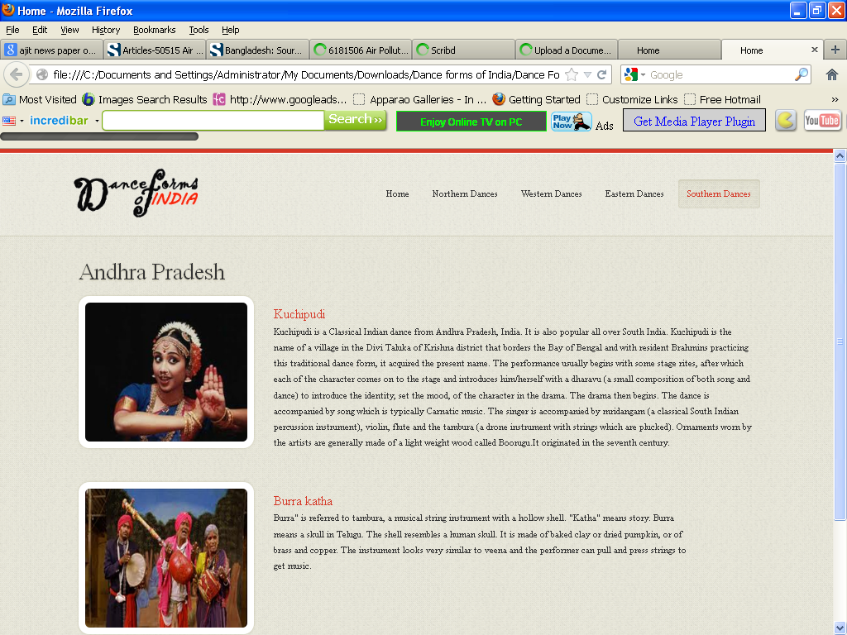

<!DOCTYPE html>

<html lang="en">

<head>

<title>Home</title>

<meta charset="utf-8">

<!--css-->

<link rel="stylesheet" href="css/reset.css" type="text/css" media="screen">

<link rel="stylesheet" href="css/style.css" type="text/css" media="screen">

<link rel="stylesheet" href="css/grid.css" type="text/css" media="screen">

<link rel="icon" href="images/favicon.ico" type="image/x-icon">

<link rel="shortcut icon" href="images/favicon.ico" type="image/x-icon" />

<link rel="stylesheet" href="css/flexslider.css" type="text/css" media="screen">

<!--js-->

<script type="text/javascript" src="js/jquery-1.7.1.min.js" ></script>

<script type="text/javascript" src="js/superfish.js"></script>

<script type="text/javascript" src="js/jquery.flexslider-min.js"></script>

<script>

jQuery(window).load(function () {

jQuery('.flexslider').flexslider({

animation: "fade",

slideshow: true,

slideshowSpeed: 7000,

animationDuration: 600,

prevText: "",

nextText: "",

controlNav: false

})

});

</script>

</head>

<body>

<!--==============================header=================================-->

<header>

<div class="line-top"></div>

<div class="main">

<div class="row-top">

<h1><a href="index.html"><img alt="" src="images/logo.gif"></a></h1>

<nav>

<ul class="sf-menu">

<li ><a href="index.html">Home</a></li>

<li><a href="#">Northern Dances</a>

<ul>

<li><a href="JnK.html">Jammu n Kashmir</a></li>

<li><a href="HP.html">Himachal Pradesh </a>

<li><a href="Uttarakhand.html">Uttarakhand</a></li>

<li><a href="Haryana.html">Haryana</a></li>

<li><a href="Punjab.html">Punjab </a>

<li><a href="Rajasthan.html">Rajasthan</a></li>

<li><a href="UP.html">Uttar Pradesh</a></li>

<li><a href="Bihar.html">Bihar</a></li>

<li><a href="Jharkhand.html">Jharkhand</a></li>

<li><a href="Chhattisgarh.html">Chhattisgarh</a></li>

<li><a href="MP.html">Madhya Pradesh</a></li>

</ul>

</li>

<li><a href="#">Western Dances</a>

<ul>

<li><a href="Maharashtra.html">Maharashtra</a></li>

<li><a href="Gujarat.html">Gujarat </a>

</ul>

</li>

<li><a href="#" >Eastern Dances</a>

<ul>

<li><a href="WB.html">West Bengal</a></li>

<li><a href="Orissa.html">Orissa </a>

<li><a href="Jharkhand.html">Jharkhand</a></li>

<li><a href="AP.html">Arunachal Pradesh</a></li>

<li><a href="Assam.html">Assam </a>

<li><a href="Manipur.html">Manipur</a></li>

<li><a href="Meghalaya.html">Meghalaya</a></li>

<li><a href="Mizoram.html">Mizoram</a></li>

<li><a href="Nagaland.html">Nagaland</a></li>

<li><a href="Sikkim.html">Sikkim</a></li>

<li><a href="Tripura.html">Tripura</a></li>

</ul>

</li>

<li class="active"><a href="#">Southern Dances </a>

<ul>

<li><a href="AndP.html">Andhra Pradesh</a></li>

<li><a href="Karnataka.html">Karnataka </a>

<li><a href="Kerala.html">Kerala</a></li>

<li><a href="TN.html">Tamil Nadu</a></li>

</ul>

</nav>

<div class="clear"></div>

</div>

</div>

</header>

<!--==============================content=================================-->

<section id="content"><div class="ic"></div>

<div class="border-horiz"></div>

<div class="container_12">

<article class="grid_8">

<h3>Andhra Pradesh</h3>

<ul class="list-recipes">

<li>

<figure class="box-img"><img src="images/AndP1.jpg " alt="" /></figure>

<div class="overflow">

<h4>Kuchipudi</h4>

<p>Kuchipudi is a Classical Indian dance from Andhra Pradesh, India. It is also popular all over South India. Kuchipudi is the name of a village in the Divi Taluka of Krishna district that borders the Bay of Bengal and with resident Brahmins practicing this traditional dance form, it acquired the present name.

The performance usually begins with some stage rites, after which each of the character comes on to the stage and introduces him/herself with a dharavu (a small composition of both song and dance) to introduce the identity, set the mood, of the character in the drama. The drama then begins. The dance is accompanied by song which is typically Carnatic music. The singer is accompanied by mridangam (a classical South Indian percussion instrument), violin, flute and the tambura (a drone instrument with strings which are plucked). Ornaments worn by the artists are generally made of a light weight wood called Boorugu.It originated in the seventh century.</p>

</div>

<div class="clear"></div>

</li>

<li>

<figure class="box-img "><img src="images/AndP2.jpg " alt="" /></figure>

<div class="overflow" style= "width:62%" >

<h4>Burra katha</h4>

<p>Burra" is referred to tambura, a musical string instrument with a hollow shell. "Katha" means story.

Burra means a skull in Telugu. The shell resembles a human skull. It is made of baked clay or dried pumpkin, or of brass and copper. The instrument looks very similar to veena and the performer can pull and press strings to get music. </p>

</div>

<div class="clear"></div>

</li>

</ul>

</article>

<div class="clear"></div>

</div>

</section>

<!--==============================footer=================================-->

<footer>

<div class="main">

<center> <p>Some traditions of the Indian classical dance are practiced in the whole Indian subcontinent, including Pakistan and Bangladesh, with which India shares several other cultural traits. Indian mythologies play significant part in dance forms of countries in South East Asia, an example being the performances based on Ramayana in Javanese dances.</p> </center>

</div>

</footer>

</body>

</html>

**Arunachal Pradesh.htm**

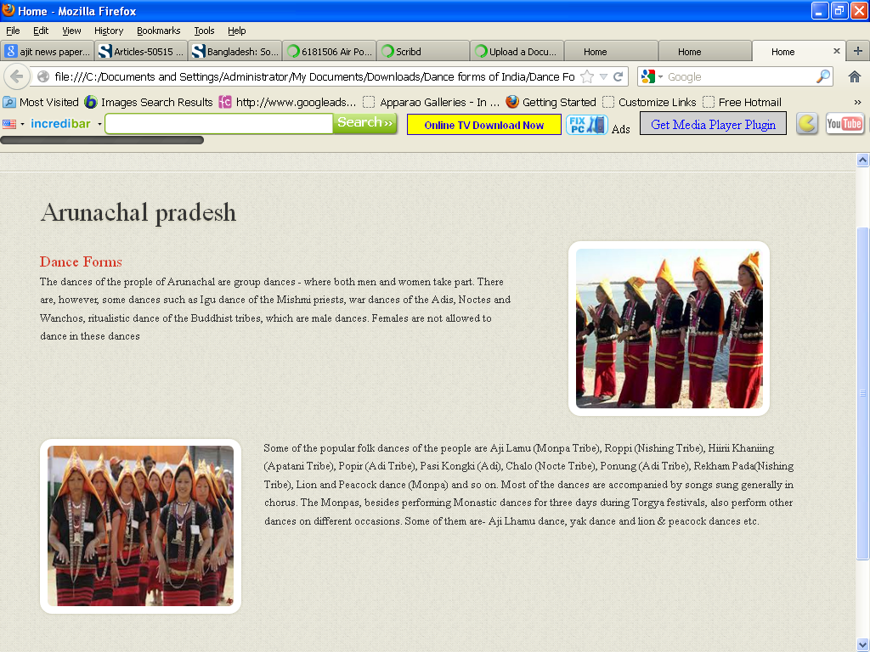

<!DOCTYPE html>

<html lang="en">

<head>

<title>Home</title>

<meta charset="utf-8">

<!--css-->

<link rel="stylesheet" href="css/reset.css" type="text/css" media="screen">

<link rel="stylesheet" href="css/style.css" type="text/css" media="screen">

<link rel="stylesheet" href="css/grid.css" type="text/css" media="screen">

<link rel="icon" href="images/favicon.ico" type="image/x-icon">

<link rel="shortcut icon" href="images/favicon.ico" type="image/x-icon" />

<link rel="stylesheet" href="css/flexslider.css" type="text/css" media="screen">

<!--js-->

<script type="text/javascript" src="js/jquery-1.7.1.min.js" ></script>

<script type="text/javascript" src="js/superfish.js"></script>

<script type="text/javascript" src="js/jquery.flexslider-min.js"></script>

<script>

jQuery(window).load(function () {

jQuery('.flexslider').flexslider({

animation: "fade",

slideshow: true,

slideshowSpeed: 7000,

animationDuration: 600,

prevText: "",

nextText: "",

controlNav: false

})

});

</script>

</head>

<body>

<!--==============================header=================================-->

<header>

<div class="line-top"></div>

<div class="main">

<div class="row-top">

<h1><a href="index.html"><img alt="" src="images/logo.gif"></a></h1>

<nav>

<ul class="sf-menu">

<li><a href="index.html">Home</a></li>

<li><a href="#">Northern Dances</a>

<ul>

<li><a href="JnK.html">Jammu n Kashmir</a></li>

<li><a href="HP.html">Himachal Pradesh </a>

<li><a href="Uttarakhand.html">Uttarakhand</a></li>

<li><a href="Haryana.html">Haryana</a></li>

<li><a href="Punjab.html">Punjab </a>

<li><a href="Rajasthan.html">Rajasthan</a></li>

<li><a href="UP.html">Uttar Pradesh</a></li>

<li><a href="Bihar.html">Bihar</a></li>

<li><a href="Jharkhand.html">Jharkhand</a></li>

<li><a href="Chhattisgarh.html">Chhattisgarh</a></li>

<li><a href="MP.html">Madhya Pradesh</a></li>

</ul>

</li>

<li><a href="#">Western Dances</a>

<ul>

<li><a href="Maharashtra.html">Maharashtra</a></li>

<li><a href="Gujarat.html">Gujarat </a>

</ul>

</li>

<li class="active"><a href="#">Eastern Dances</a>

<ul>

<li><a href="WB.html">West Bengal</a></li>

<li><a href="Orissa.html">Orissa </a>

<li><a href="Jharkhand.html">Jharkhand</a></li>

<li><a href="AP.html">Arunachal Pradesh</a></li>

<li><a href="Assam.html">Assam </a>

<li><a href="Manipur.html">Manipur</a></li>

<li><a href="Meghalaya.html">Meghalaya</a></li>

<li><a href="Mizoram.html">Mizoram</a></li>

<li><a href="Nagaland.html">Nagaland</a></li>

<li><a href="Sikkim.html">Sikkim</a></li>

<li><a href="Tripura.html">Tripura</a></li>

</ul>

</li>

<li><a href="#">Southern Dances </a>

<ul>

<li><a href="AndP.html">Andhra Pradesh</a></li>

<li><a href="Karnataka.html">Karnataka </a>

<li><a href="Kerala.html">Kerala</a></li>

<li><a href="TN.html">Tamil Nadu</a></li>

</ul>

</nav>

<div class="clear"></div>

</div>

</div>

</header>

<!--==============================content=================================-->

<section id="content"><div class="ic"></div>

<div class="border-horiz"></div>

<div class="container_12">

<article class="grid_8">

<h3>Arunachal pradesh</h3>

<ul class="list-recipes">

<li>

<div class="img-indent2"><figure class="box-img "><img src="images/AP1.jpg " alt="" /></figure></div>

<div class="overflow" style= "width:62%" >

<h4>Dance Forms</h4>

<p>The dances of the prople of Arunachal are group dances - where both men and women take part. There are, however, some dances such as Igu dance of the Mishmi priests, war dances of the Adis, Noctes and Wanchos, ritualistic dance of the Buddhist tribes, which are male dances. Females are not allowed to dance in these dances </p>

</div>

<div class="clear"></div>

</li>

<li>

<figure class="box-img"><img src="images/AP2.jpg " alt="" /></figure>

<div class="overflow">

<p>Some of the popular folk dances of the people are Aji Lamu (Monpa Tribe), Roppi (Nishing Tribe), Hiirii Khaniing (Apatani Tribe), Popir (Adi Tribe), Pasi Kongki (Adi), Chalo (Nocte Tribe), Ponung (Adi Tribe), Rekham Pada(Nishing Tribe), Lion and Peacock dance (Monpa) and so on. Most of the dances are accompanied by songs sung generally in chorus.

The Monpas, besides performing Monastic dances for three days during Torgya festivals, also perform other dances on different occasions. Some of them are- Aji Lhamu dance, yak dance and lion & peacock dances etc.</p>

</div>

<div class="clear"></div>

</li>

</ul>

</article>

<div class="clear"></div>

</div>

</section>

<!--==============================footer=================================-->

<footer>

<div class="main">

<center> <p>Some traditions of the Indian classical dance are practiced in the whole Indian subcontinent, including Pakistan and Bangladesh, with which India shares several other cultural traits. Indian mythologies play significant part in dance forms of countries in South East Asia, an example being the performances based on Ramayana in Javanese dances.</p> </center>

</div>

</footer>

</body>

</html>

**Assam.htm**

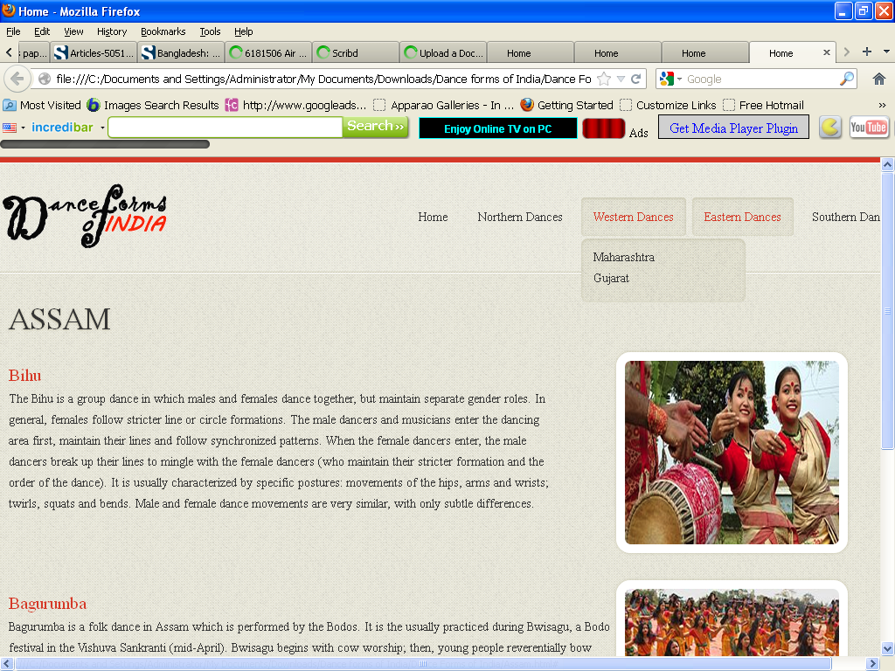

<!DOCTYPE html>

<html lang="en">

<head>

<title>Home</title>

<meta charset="utf-8">

<!--css-->

<link rel="stylesheet" href="css/reset.css" type="text/css" media="screen">

<link rel="stylesheet" href="css/style.css" type="text/css" media="screen">

<link rel="stylesheet" href="css/grid.css" type="text/css" media="screen">

<link rel="icon" href="images/favicon.ico" type="image/x-icon">

<link rel="shortcut icon" href="images/favicon.ico" type="image/x-icon" />

<link rel="stylesheet" href="css/flexslider.css" type="text/css" media="screen">

<!--js-->

<script type="text/javascript" src="js/jquery-1.7.1.min.js" ></script>

<script type="text/javascript" src="js/superfish.js"></script>

<script type="text/javascript" src="js/jquery.flexslider-min.js"></script>

<script>

jQuery(window).load(function () {

jQuery('.flexslider').flexslider({

animation: "fade",

slideshow: true,

slideshowSpeed: 7000,

animationDuration: 600,

prevText: "",

nextText: "",

controlNav: false

})

});

</script>

</head>

<body>

<!--==============================header=================================-->

<header>

<div class="line-top"></div>

<div class="main">

<div class="row-top">

<h1><a href="index.html"><img alt="" src="images/logo.gif"></a></h1>

<nav>

<ul class="sf-menu">

<li><a href="index.html">Home</a></li>

<li><a href="#">Northern Dances</a>

<ul>

<li><a href="JnK.html">Jammu n Kashmir</a></li>

<li><a href="HP.html">Himachal Pradesh </a>

<li><a href="Uttarakhand.html">Uttarakhand</a></li>

<li><a href="Haryana.html">Haryana</a></li>

<li><a href="Punjab.html">Punjab </a>

<li><a href="Rajasthan.html">Rajasthan</a></li>

<li><a href="UP.html">Uttar Pradesh</a></li>

<li><a href="Bihar.html">Bihar</a></li>

<li><a href="Jharkhand.html">Jharkhand</a></li>

<li><a href="Chhattisgarh.html">Chhattisgarh</a></li>

<li><a href="MP.html">Madhya Pradesh</a></li>

</ul>

</li>

<li><a href="#">Western Dances</a>

<ul>

<li><a href="Maharashtra.html">Maharashtra</a></li>

<li><a href="Gujarat.html">Gujarat </a>

</ul>

</li>

<li class="active"><a href="#">Eastern Dances</a>

<ul>

<li><a href="WB.html">West Bengal</a></li>

<li><a href="Orissa.html">Orissa </a>

<li><a href="Jharkhand.html">Jharkhand</a></li>

<li><a href="AP.html">Arunachal Pradesh</a></li>

<li><a href="Assam.html">Assam </a>

<li><a href="Manipur.html">Manipur</a></li>

<li><a href="Meghalaya.html">Meghalaya</a></li>

<li><a href="Mizoram.html">Mizoram</a></li>

<li><a href="Nagaland.html">Nagaland</a></li>

<li><a href="Sikkim.html">Sikkim</a></li>

<li><a href="Tripura.html">Tripura</a></li>

</ul>

</li>

<li><a href="#">Southern Dances </a>

<ul>

<li><a href="AndP.html">Andhra Pradesh</a></li>

<li><a href="Karnataka.html">Karnataka </a>

<li><a href="Kerala.html">Kerala</a></li>

<li><a href="TN.html">Tamil Nadu</a></li>

</ul>

</nav>

<div class="clear"></div>

</div>

</div>

</header>

<!--==============================content=================================-->

<section id="content"><div class="ic"></div>

<div class="border-horiz"></div>

<div class="container_12">

<article class="grid_8">

<h3>ASSAM</h3>

<ul class="list-recipes">

<li>

<div class="img-indent2"><figure class="box-img "><img src="images/Assam1.jpg " alt="" /></figure></div>

<div class="overflow" style= "width:62%" >

<h4>Bihu</h4>

<p>The Bihu is a group dance in which males and females dance together, but maintain separate gender roles. In general, females follow stricter line or circle formations. The male dancers and musicians enter the dancing area first, maintain their lines and follow synchronized patterns. When the female dancers enter, the male dancers break up their lines to mingle with the female dancers (who maintain their stricter formation and the order of the dance). It is usually characterized by specific postures: movements of the hips, arms and wrists; twirls, squats and bends. Male and female dance movements are very similar, with only subtle differences. </p>

</div>

<div class="clear"></div>

</li>

<li>

<div class="img-indent2"><figure class="box-img"><img src="images/Assam2.jpg " alt="" /></figure></div>

<div class="overflow">

<h4>Bagurumba</h4>

<p>Bagurumba is a folk dance in Assam which is performed by the Bodos. It is the usually practiced during Bwisagu, a Bodo festival in the Vishuva Sankranti (mid-April). Bwisagu begins with cow worship; then, young people reverentially bow down to their parents and elders.

After that, Bathow is worshiped by offering the deity chicken and zou (rice beer). Bodo women wearing colourful dokhna and aronai perform the Bagurumba dance (also known as the Bardwisikhla dance). It is accompanied by instruments such as the serja (a bowed instrument), sifung (flute), tharkha (split bamboo), kham or madal (long drum, made of wood and goatskin). The festival ends with a community prayer at Garjasali. This dance is performed in the Bodo-inhabited areas of Udalguri, Kokrajhar, Baksa, Chirang, Bongaigaon, Nalbari, Darrang and Sonitpur Districts.</p> </div>

<div class="clear"></div>

</li>

</ul>

</article>

<div class="clear"></div>

</div>

</section>

<!--==============================footer=================================-->

<footer>

<div class="main">

<center> <p>Some traditions of the Indian classical dance are practiced in the whole Indian subcontinent, including Pakistan and Bangladesh, with which India shares several other cultural traits. Indian mythologies play significant part in dance forms of countries in South East Asia, an example being the performances based on Ramayana in Javanese dances.</p> </center>

</div>

</footer>

</body>

</html>

**Bihar.htm**

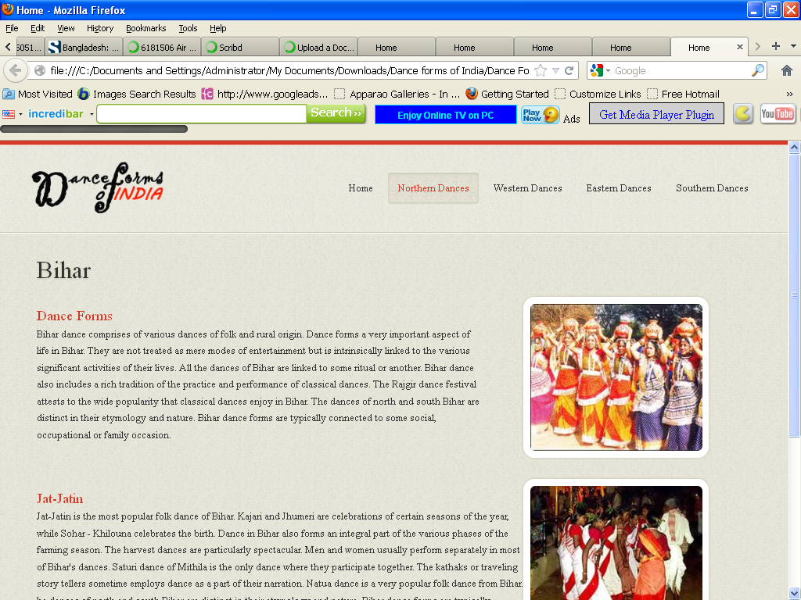

<!DOCTYPE html>

<html lang="en">

<head>

<title>Home</title>

<meta charset="utf-8">

<!--css-->

<link rel="stylesheet" href="css/reset.css" type="text/css" media="screen">

<link rel="stylesheet" href="css/style.css" type="text/css" media="screen">

<link rel="stylesheet" href="css/grid.css" type="text/css" media="screen">

<link rel="icon" href="images/favicon.ico" type="image/x-icon">

<link rel="shortcut icon" href="images/favicon.ico" type="image/x-icon" />

<link rel="stylesheet" href="css/flexslider.css" type="text/css" media="screen">

<!--js-->

<script type="text/javascript" src="js/jquery-1.7.1.min.js" ></script>

<script type="text/javascript" src="js/superfish.js"></script>

<script type="text/javascript" src="js/jquery.flexslider-min.js"></script>

<script>

jQuery(window).load(function () {

jQuery('.flexslider').flexslider({

animation: "fade",

slideshow: true,

slideshowSpeed: 7000,

animationDuration: 600,

prevText: "",

nextText: "",

controlNav: false

})

});

</script>

</head>

<body>

<!--==============================header=================================-->

<header>

<div class="line-top"></div>

<div class="main">

<div class="row-top">

<h1><a href="index.html"><img alt="" src="images/logo.gif"></a></h1>

<nav>

<ul class="sf-menu">

<li><a href="index.html">Home</a></li>

<li class="active"><a href="#">Northern Dances</a>

<ul>

<li><a href="JnK.html">Jammu n Kashmir</a></li>

<li><a href="HP.html">Himachal Pradesh </a>

<li><a href="Uttarakhand.html">Uttarakhand</a></li>

<li><a href="Haryana.html">Haryana</a></li>

<li><a href="Punjab.html">Punjab </a>

<li><a href="Rajasthan.html">Rajasthan</a></li>

<li><a href="UP.html">Uttar Pradesh</a></li>

<li><a href="Bihar.html">Bihar</a></li>

<li><a href="Jharkhand.html">Jharkhand</a></li>

<li><a href="Chhattisgarh.html">Chhattisgarh</a></li>

<li><a href="MP.html">Madhya Pradesh</a></li>

</ul>

</li>

<li><a href="#">Western Dances</a>

<ul>

<li><a href="Maharashtra.html">Maharashtra</a></li>

<li><a href="Gujarat.html">Gujarat </a>

</ul>

</li>

<li><a href="#">Eastern Dances</a>

<ul>

<li><a href="WB.html">West Bengal</a></li>

<li><a href="Orissa.html">Orissa </a>

<li><a href="Jharkhand.html">Jharkhand</a></li>

<li><a href="AP.html">Arunachal Pradesh</a></li>

<li><a href="Assam.html">Assam </a>

<li><a href="Manipur.html">Manipur</a></li>

<li><a href="Meghalaya.html">Meghalaya</a></li>

<li><a href="Mizoram.html">Mizoram</a></li>

<li><a href="Nagaland.html">Nagaland</a></li>

<li><a href="Sikkim.html">Sikkim</a></li>

<li><a href="Tripura.html">Tripura</a></li>

</ul>

</li>

<li><a href="#">Southern Dances </a>

<ul>

<li><a href="AndP.html">Andhra Pradesh</a></li>

<li><a href="Karnataka.html">Karnataka </a>

<li><a href="Kerala.html">Kerala</a></li>

<li><a href="TN.html">Tamil Nadu</a></li>

</ul>

</nav>

<div class="clear"></div>

</div>

</div>

</header>

<!--==============================content=================================-->

<section id="content"><div class="ic"></div>

<div class="border-horiz"></div>

<div class="container_12">

<article class="grid_8">

<h3>Bihar</h3>

<ul class="list-recipes">

<li>

<div class="img-indent2"><figure class="box-img "><img src="images/Bihar1.jpg " alt="" /></figure></div>

<div class="overflow" style= "width:62%" >

<h4>Dance Forms</h4>

<p>Bihar dance comprises of various dances of folk and rural origin. Dance forms a very important aspect of life in Bihar. They are not treated as mere modes of entertainment but is intrinsically linked to the various significant activities of their lives.

All the dances of Bihar are linked to some ritual or another. Bihar dance also includes a rich tradition of the practice and performance of classical dances. The Rajgir dance festival attests to the wide popularity that classical dances enjoy in Bihar.

The dances of north and south Bihar are distinct in their etymology and nature. Bihar dance forms are typically connected to some social, occupational or family occasion.

</p>

</div>

<div class="clear"></div>

</li>

<li>

<div class="img-indent2"><figure class="box-img"><img src="images/Bihar2.jpg " alt="" /></figure></div>

<div class="overflow">

<h4>Jat-Jatin</h4>

<p>Jat-Jatin is the most popular folk dance of Bihar. Kajari and Jhumeri are celebrations of certain seasons of the year, while Sohar - Khilouna celebrates the birth. Dance in Bihar also forms an integral part of the various phases of the farming season. The harvest dances are particularly spectacular. Men and women usually perform separately in most of Bihar's dances. Saturi dance of Mithila is the only dance where they participate together. The kathaks or traveling story tellers sometime employs dance as a part of their narration. Natua dance is a very popular folk dance from Bihar. he dances of north and south Bihar are distinct in their etymology and nature. Bihar dance forms are typically connected to some social, occupational or family occasion. Jat-Jatin is the most popular folk dance of Bihar. Kajari and Jhumeri are celebrations of certain seasons of the year, while Sohar - Khilouna celebrates the birth. Dance in Bihar also forms an integral part of the various phases of the farming season. The harvest dances are particularly spectacular.

</p>

</div>

<div class="clear"></div>

</li>

</ul>

</article>

<div class="clear"></div>

</div>

</section>

<!--==============================footer=================================-->

<footer>

<div class="main">

<center> <p>Some traditions of the Indian classical dance are practiced in the whole Indian subcontinent, including Pakistan and Bangladesh, with which India shares several other cultural traits. Indian mythologies play significant part in dance forms of countries in South East Asia, an example being the performances based on Ramayana in Javanese dances.</p> </center>

</div>

</footer>

</body>

</html>

**Chhatisgarh.htm**

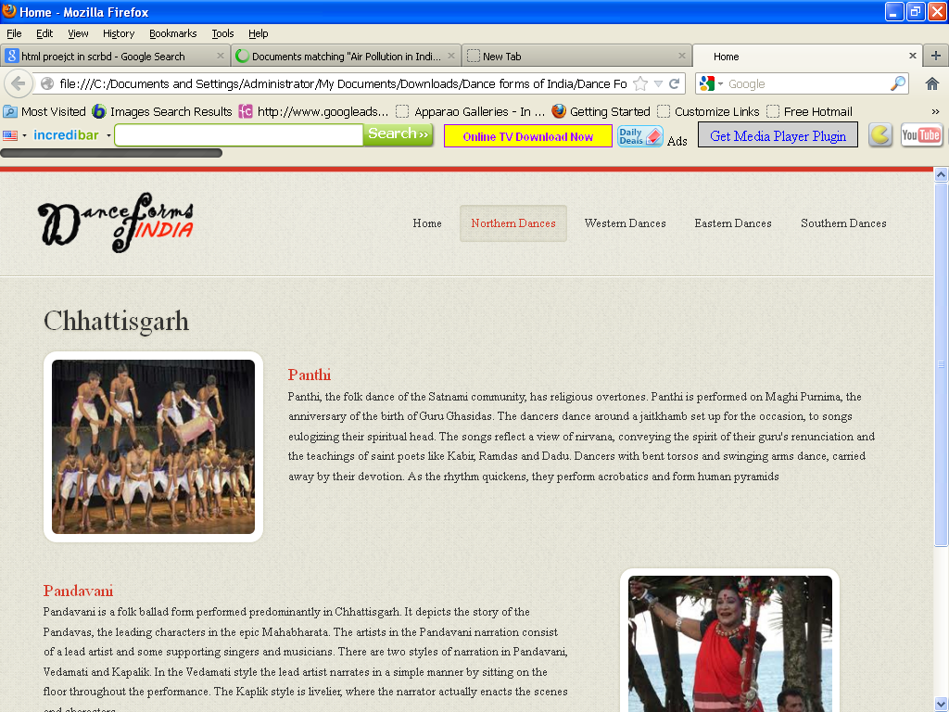

<!DOCTYPE html>

<html lang="en">

<head>

<title>Home</title>

<meta charset="utf-8">

<!--css-->

<link rel="stylesheet" href="css/reset.css" type="text/css" media="screen">

<link rel="stylesheet" href="css/style.css" type="text/css" media="screen">

<link rel="stylesheet" href="css/grid.css" type="text/css" media="screen">

<link rel="icon" href="images/favicon.ico" type="image/x-icon">

<link rel="shortcut icon" href="images/favicon.ico" type="image/x-icon" />

<link rel="stylesheet" href="css/flexslider.css" type="text/css" media="screen">

<!--js-->

<script type="text/javascript" src="js/jquery-1.7.1.min.js" ></script>

<script type="text/javascript" src="js/superfish.js"></script>

<script type="text/javascript" src="js/jquery.flexslider-min.js"></script>

<script>

jQuery(window).load(function () {

jQuery('.flexslider').flexslider({

animation: "fade",

slideshow: true,

slideshowSpeed: 7000,

animationDuration: 600,

prevText: "",

nextText: "",

controlNav: false

})

});

</script>

</head>

<body>

<!--==============================header=================================-->

<header>

<div class="line-top"></div>

<div class="main">

<div class="row-top">

<h1><a href="index.html"><img alt="" src="images/logo.gif"></a></h1>

<nav>

<ul class="sf-menu">

<li><a href="index.html">Home</a></li>

<li class="active"><a href="#">Northern Dances</a>

<ul>

<li><a href="JnK.html">Jammu n Kashmir</a></li>

<li><a href="HP.html">Himachal Pradesh </a>

<li><a href="Uttarakhand.html">Uttarakhand</a></li>

<li><a href="Haryana.html">Haryana</a></li>

<li><a href="Punjab.html">Punjab </a>

<li><a href="Rajasthan.html">Rajasthan</a></li>

<li><a href="UP.html">Uttar Pradesh</a></li>

<li><a href="Bihar.html">Bihar</a></li>

<li><a href="Jharkhand.html">Jharkhand</a></li>

<li><a href="Chhattisgarh.html">Chhattisgarh</a></li>

<li><a href="MP.html">Madhya Pradesh</a></li>

</ul>

</li>

<li><a href="#">Western Dances</a>

<ul>

<li><a href="Maharashtra.html">Maharashtra</a></li>

<li><a href="Gujarat.html">Gujarat </a>

</ul>

</li>

<li><a href="#">Eastern Dances</a>

<ul>

<li><a href="WB.html">West Bengal</a></li>

<li><a href="Orissa.html">Orissa </a>

<li><a href="Jharkhand.html">Jharkhand</a></li>

<li><a href="AP.html">Arunachal Pradesh</a></li>

<li><a href="Assam.html">Assam </a>

<li><a href="Manipur.html">Manipur</a></li>

<li><a href="Meghalaya.html">Meghalaya</a></li>

<li><a href="Mizoram.html">Mizoram</a></li>

<li><a href="Nagaland.html">Nagaland</a></li>

<li><a href="Sikkim.html">Sikkim</a></li>

<li><a href="Tripura.html">Tripura</a></li>

</ul>

</li>

<li><a href="#">Southern Dances </a>

<ul>

<li><a href="AndP.html">Andhra Pradesh</a></li>

<li><a href="Karnataka.html">Karnataka </a>

<li><a href="Kerala.html">Kerala</a></li>

<li><a href="TN.html">Tamil Nadu</a></li>

</ul>

</nav>

<div class="clear"></div>

</div>

</div>

</header>

<!--==============================content=================================-->

<section id="content"><div class="ic"></div>

<div class="border-horiz"></div>

<div class="container_12">

<article class="grid_8">

<h3>Chhattisgarh</h3>

<ul class="list-recipes">

<li>

<figure class="box-img"><img src="images/Ch1.jpg " alt="" /></figure>

<div class="overflow">

<h4>Panthi</h4>

<p>Panthi, the folk dance of the Satnami community, has religious overtones. Panthi is performed on Maghi Purnima, the anniversary of the birth of Guru Ghasidas. The dancers dance around a jaitkhamb set up for the occasion, to songs eulogizing their spiritual head. The songs reflect a view of nirvana, conveying the spirit of their guru's renunciation and the teachings of saint poets like Kabir, Ramdas and Dadu. Dancers with bent torsos and swinging arms dance, carried away by their devotion. As the rhythm quickens, they perform acrobatics and form human pyramids </p> </div>

<div class="clear"></div>

</li>

<li>

<div class="img-indent2"><figure class="box-img "><img src="images/Ch2.jpg " alt="" /></figure></div>

<div class="overflow" style= "width:62%" >

<h4>Pandavani</h4>

<p>Pandavani is a folk ballad form performed predominantly in Chhattisgarh. It depicts the story of the Pandavas, the leading characters in the epic Mahabharata. The artists in the Pandavani narration consist of a lead artist and some supporting singers and musicians. There are two styles of narration in Pandavani, Vedamati and Kapalik. In the Vedamati style the lead artist narrates in a simple manner by sitting on the floor throughout the performance. The Kaplik style is livelier, where the narrator actually enacts the scenes and characters.</p>

</div>

<div class="clear"></div>

</li>

</ul>

</article>

<div class="clear"></div>

</div>

</section>

<!--==============================footer=================================-->

<footer>

<div class="main">

<center> <p>Some traditions of the Indian classical dance are practiced in the whole Indian subcontinent, including Pakistan and Bangladesh, with which India shares several other cultural traits. Indian mythologies play significant part in dance forms of countries in South East Asia, an example being the performances based on Ramayana in Javanese dances.</p> </center>

</div>

</footer>

</body>

</html>

**Gujarat.htm**

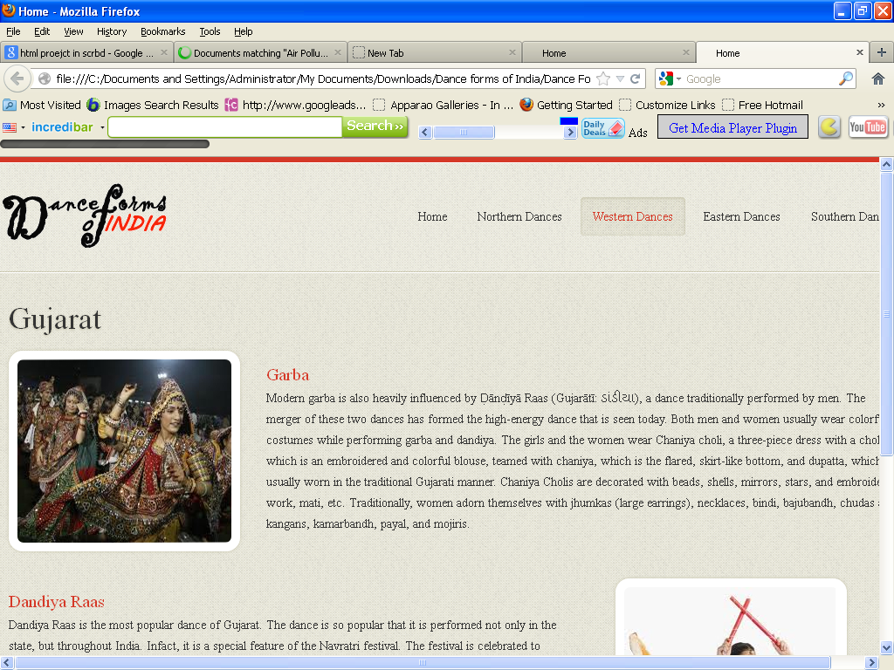

<!DOCTYPE html>

<html lang="en">

<head>

<title>Home</title>

<meta charset="utf-8">

<!--css-->

<link rel="stylesheet" href="css/reset.css" type="text/css" media="screen">

<link rel="stylesheet" href="css/style.css" type="text/css" media="screen">

<link rel="stylesheet" href="css/grid.css" type="text/css" media="screen">

<link rel="icon" href="images/favicon.ico" type="image/x-icon">

<link rel="shortcut icon" href="images/favicon.ico" type="image/x-icon" />

<link rel="stylesheet" href="css/flexslider.css" type="text/css" media="screen">

<!--js-->

<script type="text/javascript" src="js/jquery-1.7.1.min.js" ></script>

<script type="text/javascript" src="js/superfish.js"></script>

<script type="text/javascript" src="js/jquery.flexslider-min.js"></script>

<script>

jQuery(window).load(function () {

jQuery('.flexslider').flexslider({

animation: "fade",

slideshow: true,

slideshowSpeed: 7000,

animationDuration: 600,

prevText: "",

nextText: "",

controlNav: false

})

});

</script>

</head>

<body>

<!--==============================header=================================-->

<header>

<div class="line-top"></div>

<div class="main">

<div class="row-top">

<h1><a href="index.html"><img alt="" src="images/logo.gif"></a></h1>

<nav>

<ul class="sf-menu">

<li ><a href="index.html">Home</a></li>

<li><a href="#">Northern Dances</a>

<ul>

<li><a href="JnK.html">Jammu n Kashmir</a></li>

<li><a href="HP.html">Himachal Pradesh </a>

<li><a href="Uttarakhand.html">Uttarakhand</a></li>

<li><a href="Haryana.html">Haryana</a></li>

<li><a href="Punjab.html">Punjab </a>

<li><a href="Rajasthan.html">Rajasthan</a></li>

<li><a href="UP.html">Uttar Pradesh</a></li>

<li><a href="Bihar.html">Bihar</a></li>

<li><a href="Jharkhand.html">Jharkhand</a></li>

<li><a href="Chhattisgarh.html">Chhattisgarh</a></li>

<li><a href="MP.html">Madhya Pradesh</a></li>

</ul>

</li>

<li class="active" ><a href="#">Western Dances</a>

<ul>

<li><a href="Maharashtra.html">Maharashtra</a></li>

<li><a href="Gujarat.html">Gujarat </a>

</ul>

</li>

<li><a href="#">Eastern Dances</a>

<ul>

<li><a href="WB.html">West Bengal</a></li>

<li><a href="Orissa.html">Orissa </a>

<li><a href="Jharkhand.html">Jharkhand</a></li>

<li><a href="AP.html">Arunachal Pradesh</a></li>

<li><a href="Assam.html">Assam </a>

<li><a href="Manipur.html">Manipur</a></li>

<li><a href="Meghalaya.html">Meghalaya</a></li>

<li><a href="Mizoram.html">Mizoram</a></li>

<li><a href="Nagaland.html">Nagaland</a></li>

<li><a href="Sikkim.html">Sikkim</a></li>

<li><a href="Tripura.html">Tripura</a></li>

</ul>

</li>

<li><a href="#">Southern Dances </a>

<ul>

<li><a href="AndP.html">Andhra Pradesh</a></li>

<li><a href="Karnataka.html">Karnataka </a>

<li><a href="Kerala.html">Kerala</a></li>

<li><a href="TN.html">Tamil Nadu</a></li>

</ul>

</nav>

<div class="clear"></div>

</div>

</div>

</header>

<!--==============================content=================================-->

<section id="content"><div class="ic"></div>

<div class="border-horiz"></div>

<div class="container_12">

<article class="grid_8">

<h3>Gujarat</h3>

<ul class="list-recipes">

<li>

<figure class="box-img"><img src="images/gu1.jpg " alt="" /></figure>

<div class="overflow">

<h4>Garba</h4>

<p>Modern garba is also heavily influenced by Ḍānḍīyā Raas (Gujarātī: ડાંડીયા), a dance traditionally performed by men. The merger of these two dances has formed the high-energy dance that is seen today.

Both men and women usually wear colorful costumes while performing garba and dandiya. The girls and the women wear Chaniya choli, a three-piece dress with a choli, which is an embroidered and colorful blouse, teamed with chaniya, which is the flared, skirt-like bottom, and dupatta, which is usually worn in the traditional Gujarati manner. Chaniya Cholis are decorated with beads, shells, mirrors, stars, and embroidery work, mati, etc. Traditionally, women adorn themselves with jhumkas (large earrings), necklaces, bindi, bajubandh, chudas and kangans, kamarbandh, payal, and mojiris.</p>

</div>

<div class="clear"></div>

</li>

<li>

<div class="img-indent2"><figure class="box-img "><img src="images/gu2.jpg " alt="" /></figure></div>

<div class="overflow" style= "width:62%" >

<h4>Dandiya Raas</h4>

<p>Dandiya Raas is the most popular dance of Gujarat. The dance is so popular that it is performed not only in the state, but throughout India. Infact, it is a special feature of the Navratri festival. The festival is celebrated to pay homage to the nine incarnations of Mata Amb, the Mother Goddess. People observe fasts on all nine days of the festival and pay regular visits to temples. </p>

</div>

<div class="clear"></div>

</li>

</ul>

</article>

<div class="clear"></div>

</div>

</section>

<!--==============================footer=================================-->

<footer>

<div class="main">

<center> <p>Some traditions of the Indian classical dance are practiced in the whole Indian subcontinent, including Pakistan and Bangladesh, with which India shares several other cultural traits. Indian mythologies play significant part in dance forms of countries in South East Asia, an example being the performances based on Ramayana in Javanese dances.</p> </center>

</div>

</footer>

</body>

</html>

**Haryana.htm**

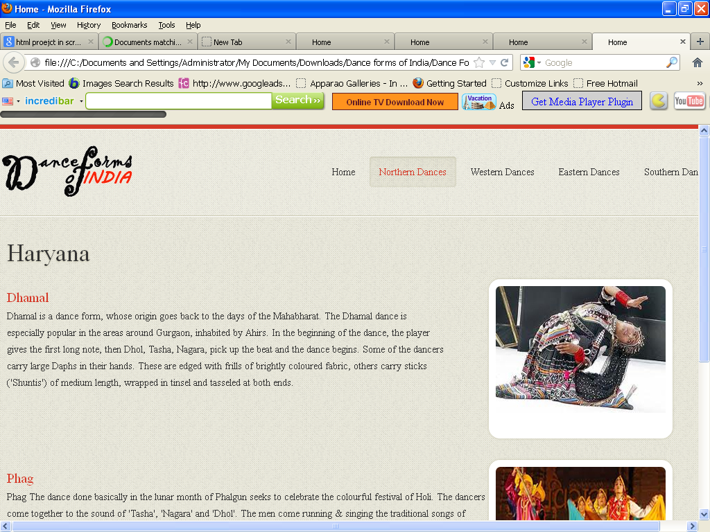

<!DOCTYPE html>

<html lang="en">

<head>

<title>Home</title>

<meta charset="utf-8">

<!--css-->

<link rel="stylesheet" href="css/reset.css" type="text/css" media="screen">

<link rel="stylesheet" href="css/style.css" type="text/css" media="screen">

<link rel="stylesheet" href="css/grid.css" type="text/css" media="screen">

<link rel="icon" href="images/favicon.ico" type="image/x-icon">

<link rel="shortcut icon" href="images/favicon.ico" type="image/x-icon" />

<link rel="stylesheet" href="css/flexslider.css" type="text/css" media="screen">

<!--js-->

<script type="text/javascript" src="js/jquery-1.7.1.min.js" ></script>

<script type="text/javascript" src="js/superfish.js"></script>

<script type="text/javascript" src="js/jquery.flexslider-min.js"></script>

<script>

jQuery(window).load(function () {

jQuery('.flexslider').flexslider({

animation: "fade",

slideshow: true,

slideshowSpeed: 7000,

animationDuration: 600,

prevText: "",

nextText: "",

controlNav: false

})

});

</script>

</head>

<body>

<!--==============================header=================================-->

<header>

<div class="line-top"></div>

<div class="main">

<div class="row-top">

<h1><a href="index.html"><img alt="" src="images/logo.gif"></a></h1>

<nav>

<ul class="sf-menu">

<li ><a href="index.html">Home</a></li>

<li class="active"><a href="#">Northern Dances</a>

<ul>

<li><a href="JnK.html">Jammu n Kashmir</a></li>

<li><a href="HP.html">Himachal Pradesh </a>

<li><a href="Uttarakhand.html">Uttarakhand</a></li>

<li><a href="Haryana.html">Haryana</a></li>

<li><a href="Punjab.html">Punjab </a>

<li><a href="Rajasthan.html">Rajasthan</a></li>

<li><a href="UP.html">Uttar Pradesh</a></li>

<li><a href="Bihar.html">Bihar</a></li>

<li><a href="Jharkhand.html">Jharkhand</a></li>

<li><a href="Chhattisgarh.html">Chhattisgarh</a></li>

<li><a href="MP.html">Madhya Pradesh</a></li>

</ul>

</li>

<li><a href="#">Western Dances</a>

<ul>

<li><a href="Maharashtra.html">Maharashtra</a></li>

<li><a href="Gujarat.html">Gujarat </a>

</ul>

</li>

<li><a href="#">Eastern Dances</a>

<ul>

<li><a href="WB.html">West Bengal</a></li>

<li><a href="Orissa.html">Orissa </a>

<li><a href="Jharkhand.html">Jharkhand</a></li>

<li><a href="AP.html">Arunachal Pradesh</a></li>

<li><a href="Assam.html">Assam </a>

<li><a href="Manipur.html">Manipur</a></li>

<li><a href="Meghalaya.html">Meghalaya</a></li>

<li><a href="Mizoram.html">Mizoram</a></li>

<li><a href="Nagaland.html">Nagaland</a></li>

<li><a href="Sikkim.html">Sikkim</a></li>

<li><a href="Tripura.html">Tripura</a></li>

</ul>

</li>

<li><a href="#">Southern Dances </a>

<ul>

<li><a href="AndP.html">Andhra Pradesh</a></li>

<li><a href="Karnataka.html">Karnataka </a>

<li><a href="Kerala.html">Kerala</a></li>

<li><a href="TN.html">Tamil Nadu</a></li>

</ul>

</nav>

<div class="clear"></div>

</div>

</div>

</header>

<!--==============================content=================================-->

<section id="content"><div class="ic"></div>

<div class="border-horiz"></div>

<div class="container_12">

<article class="grid_8">

<h3>Haryana</h3>

<ul class="list-recipes">

<li>

<div class="img-indent2"><figure class="box-img "><img src="images/Hr1.jpg " alt="" /></figure></div>

<div class="overflow" style= "width:62%" >

<h4>Dhamal</h4>

<p>

Dhamal is a dance form, whose origin goes back to the days of the Mahabharat. The Dhamal dance is especially popular in the areas around Gurgaon, inhabited by Ahirs. In the beginning of the dance, the player gives the first long note, then Dhol, Tasha, Nagara, pick up the beat and the dance begins. Some of the dancers carry large Daphs in their hands. These are edged with frills of brightly coloured fabric, others carry sticks ('Shuntis') of medium length, wrapped in tinsel and tasseled at both ends.

</p>

</div>

<div class="clear"></div>

</li>

<li>

<div class="img-indent2"><figure class="box-img"><img src="images/Hr2.jpg " alt="" /></figure></div>

<div class="overflow">

<h4>Phag</h4>

<p>Phag

The dance done basically in the lunar month of Phalgun seeks to celebrate the colourful festival of Holi. The dancers come together to the sound of 'Tasha', 'Nagara' and 'Dhol'. The men come running & singing the traditional songs of 'Phalgun', followed by women carrying 'Koraras', the knotted lengths of cloths. They run about the men hitting with the 'Koraras' while men defend themselves as best as they can with 'Shuntis'

</p>

</div>

<div class="clear"></div>

</li>

</ul>

</article>

<div class="clear"></div>

</div>

</section>

<!--==============================footer=================================-->

<footer>

<div class="main">

<center> <p>Some traditions of the Indian classical dance are practiced in the whole Indian subcontinent, including Pakistan and Bangladesh, with which India shares several other cultural traits. Indian mythologies play significant part in dance forms of countries in South East Asia, an example being the performances based on Ramayana in Javanese dances.</p> </center>

</div>

</footer>

</body>

</html>

**Himachal Pradesh.htm**

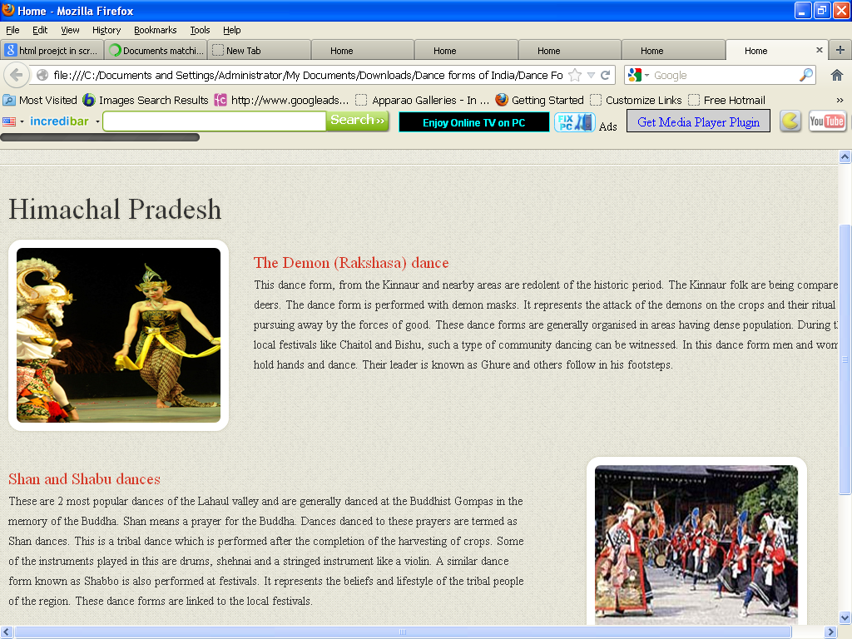

<!DOCTYPE html>

<html lang="en">

<head>

<title>Home</title>

<meta charset="utf-8">

<!--css-->

<link rel="stylesheet" href="css/reset.css" type="text/css" media="screen">

<link rel="stylesheet" href="css/style.css" type="text/css" media="screen">

<link rel="stylesheet" href="css/grid.css" type="text/css" media="screen">

<link rel="icon" href="images/favicon.ico" type="image/x-icon">

<link rel="shortcut icon" href="images/favicon.ico" type="image/x-icon" />

<link rel="stylesheet" href="css/flexslider.css" type="text/css" media="screen">

<!--js-->

<script type="text/javascript" src="js/jquery-1.7.1.min.js" ></script>

<script type="text/javascript" src="js/superfish.js"></script>

<script type="text/javascript" src="js/jquery.flexslider-min.js"></script>

<script>

jQuery(window).load(function () {

jQuery('.flexslider').flexslider({

animation: "fade",

slideshow: true,

slideshowSpeed: 7000,

animationDuration: 600,

prevText: "",

nextText: "",

controlNav: false

})

});

</script>

</head>

<body>

<!--==============================header=================================-->

<header>

<div class="line-top"></div>

<div class="main">

<div class="row-top">

<h1><a href="index.html"><img alt="" src="images/logo.gif"></a></h1>

<nav>

<ul class="sf-menu">

<li><a href="index.html">Home</a></li>

<li class="active"><a href="#">Northern Dances</a>

<ul>

<li><a href="JnK.html">Jammu n Kashmir</a></li>

<li><a href="HP.html">Himachal Pradesh </a>

<li><a href="Uttarakhand.html">Uttarakhand</a></li>

<li><a href="Haryana.html">Haryana</a></li>

<li><a href="Punjab.html">Punjab </a>

<li><a href="Rajasthan.html">Rajasthan</a></li>

<li><a href="UP.html">Uttar Pradesh</a></li>

<li><a href="Bihar.html">Bihar</a></li>

<li><a href="Jharkhand.html">Jharkhand</a></li>

<li><a href="Chhattisgarh.html">Chhattisgarh</a></li>

<li><a href="MP.html">Madhya Pradesh</a></li>

</ul>

</li>

<li><a href="#">Western Dances</a>

<ul>

<li><a href="Maharashtra.html">Maharashtra</a></li>

<li><a href="Gujarat.html">Gujarat </a>

</ul>

</li>

<li><a href="#">Eastern Dances</a>

<ul>

<li><a href="WB.html">West Bengal</a></li>

<li><a href="Orissa.html">Orissa </a>

<li><a href="Jharkhand.html">Jharkhand</a></li>

<li><a href="AP.html">Arunachal Pradesh</a></li>

<li><a href="Assam.html">Assam </a>

<li><a href="Manipur.html">Manipur</a></li>

<li><a href="Meghalaya.html">Meghalaya</a></li>

<li><a href="Mizoram.html">Mizoram</a></li>

<li><a href="Nagaland.html">Nagaland</a></li>

<li><a href="Sikkim.html">Sikkim</a></li>

<li><a href="Tripura.html">Tripura</a></li>

</ul>

</li>

<li><a href="#">Southern Dances </a>

<ul>

<li><a href="AndP.html">Andhra Pradesh</a></li>

<li><a href="Karnataka.html">Karnataka </a>

<li><a href="Kerala.html">Kerala</a></li>

<li><a href="TN.html">Tamil Nadu</a></li>

</ul>

</nav>

<div class="clear"></div>

</div>

</div>

</header>

<!--==============================content=================================-->

<section id="content"><div class="ic"></div>

<div class="border-horiz"></div>

<div class="container_12">

<article class="grid_8">

<h3>Himachal Pradesh</h3>

<ul class="list-recipes">

<li>

<figure class="box-img"><img src="images/hp1.jpg " alt="" /></figure>

<div class="overflow">

<h4>The Demon (Rakshasa) dance</h4>

<p>This dance form, from the Kinnaur and nearby areas are redolent of the historic period. The Kinnaur folk are being compared to deers. The dance form is performed with demon masks. It represents the attack of the demons on the crops and their ritual pursuing away by the forces of good. These dance forms are generally organised in areas having dense population. During their local festivals like Chaitol and Bishu, such a type of community dancing can be witnessed. In this dance form men and women hold hands and dance. Their leader is known as Ghure and others follow in his footsteps.</p>

</div>

<div class="clear"></div>

</li>

<li>

<div class="img-indent2"><figure class="box-img "><img src="images/hp2.jpg " alt="" /></figure></div>

<div class="overflow" style= "width:62%" >

<h4>Shan and Shabu dances</h4>

<p>These are 2 most popular dances of the Lahaul valley and are generally danced at the Buddhist Gompas in the memory of the Buddha. Shan means a prayer for the Buddha. Dances danced to these prayers are termed as Shan dances. This is a tribal dance which is performed after the completion of the harvesting of crops. Some of the instruments played in this are drums, shehnai and a stringed instrument like a violin.

A similar dance form known as Shabbo is also performed at festivals. It represents the beliefs and lifestyle of the tribal people of the region. These dance forms are linked to the local festivals.

</p>

</div>

<div class="clear"></div>

</li>

</ul>

</article>

<div class="clear"></div>

</div>

</section>

<!--==============================footer=================================-->

<footer>

<div class="main">

<center> <p>Some traditions of the Indian classical dance are practiced in the whole Indian subcontinent, including Pakistan and Bangladesh, with which India shares several other cultural traits. Indian mythologies play significant part in dance forms of countries in South East Asia, an example being the performances based on Ramayana in Javanese dances.</p> </center>

</div>

</footer>

</body>

</html>

**Jharkhand.htm**

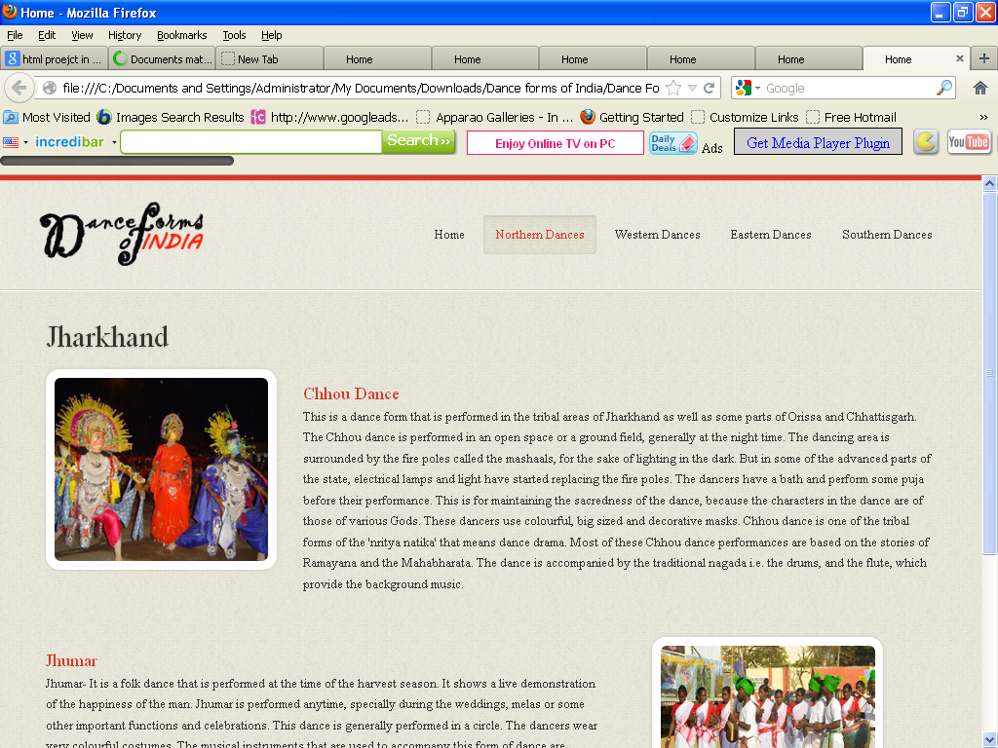

<!DOCTYPE html>

<html lang="en">

<head>

<title>Home</title>

<meta charset="utf-8">

<!--css-->

<link rel="stylesheet" href="css/reset.css" type="text/css" media="screen">

<link rel="stylesheet" href="css/style.css" type="text/css" media="screen">

<link rel="stylesheet" href="css/grid.css" type="text/css" media="screen">

<link rel="icon" href="images/favicon.ico" type="image/x-icon">

<link rel="shortcut icon" href="images/favicon.ico" type="image/x-icon" />

<link rel="stylesheet" href="css/flexslider.css" type="text/css" media="screen">

<!--js-->

<script type="text/javascript" src="js/jquery-1.7.1.min.js" ></script>

<script type="text/javascript" src="js/superfish.js"></script>

<script type="text/javascript" src="js/jquery.flexslider-min.js"></script>

<script>

jQuery(window).load(function () {

jQuery('.flexslider').flexslider({

animation: "fade",

slideshow: true,

slideshowSpeed: 7000,

animationDuration: 600,

prevText: "",

nextText: "",

controlNav: false

})

});

</script>

</head>

<body>

<!--==============================header=================================-->

<header>

<div class="line-top"></div>

<div class="main">

<div class="row-top">

<h1><a href="index.html"><img alt="" src="images/logo.gif"></a></h1>

<nav>

<ul class="sf-menu">

<li><a href="index.html">Home</a></li>

<li class="active"><a href="#">Northern Dances</a>

<ul>

<li><a href="JnK.html">Jammu n Kashmir</a></li>

<li><a href="HP.html">Himachal Pradesh </a>

<li><a href="Uttarakhand.html">Uttarakhand</a></li>

<li><a href="Haryana.html">Haryana</a></li>

<li><a href="Punjab.html">Punjab </a>

<li><a href="Rajasthan.html">Rajasthan</a></li>

<li><a href="UP.html">Uttar Pradesh</a></li>

<li><a href="Bihar.html">Bihar</a></li>

<li><a href="Jharkhand.html">Jharkhand</a></li>

<li><a href="Chhattisgarh.html">Chhattisgarh</a></li>

<li><a href="MP.html">Madhya Pradesh</a></li>

</ul>

</li>

<li><a href="#">Western Dances</a>

<ul>

<li><a href="Maharashtra.html">Maharashtra</a></li>

<li><a href="Gujarat.html">Gujarat </a>

</ul>

</li>

<li><a href="#">Eastern Dances</a>

<ul>

<li><a href="WB.html">West Bengal</a></li>

<li><a href="Orissa.html">Orissa </a>

<li><a href="Jharkhand.html">Jharkhand</a></li>

<li><a href="AP.html">Arunachal Pradesh</a></li>

<li><a href="Assam.html">Assam </a>

<li><a href="Manipur.html">Manipur</a></li>

<li><a href="Meghalaya.html">Meghalaya</a></li>

<li><a href="Mizoram.html">Mizoram</a></li>

<li><a href="Nagaland.html">Nagaland</a></li>

<li><a href="Sikkim.html">Sikkim</a></li>

<li><a href="Tripura.html">Tripura</a></li>

</ul>

</li>

<li><a href="#">Southern Dances </a>

<ul>

<li><a href="AndP.html">Andhra Pradesh</a></li>

<li><a href="Karnataka.html">Karnataka </a>

<li><a href="Kerala.html">Kerala</a></li>

<li><a href="TN.html">Tamil Nadu</a></li>

</ul>

</nav>

<div class="clear"></div>

</div>

</div>

</header>

<!--==============================content=================================-->

<section id="content"><div class="ic"></div>

<div class="border-horiz"></div>

<div class="container_12">

<article class="grid_8">

<h3>Jharkhand</h3>

<ul class="list-recipes">

<li>

<figure class="box-img"><img src="images/jh1.jpg " alt="" /></figure>

<div class="overflow">

<h4>Chhou Dance</h4>

<p>This is a dance form that is performed in the tribal areas of Jharkhand as well as some parts of Orissa and Chhattisgarh. The Chhou dance is performed in an open space or a ground field, generally at the night time. The dancing area is surrounded by the fire poles called the mashaals, for the sake of lighting in the dark. But in some of the advanced parts of the state, electrical lamps and light have started replacing the fire poles. The dancers have a bath and perform some puja before their performance. This is for maintaining the sacredness of the dance, because the characters in the dance are of those of various Gods.

These dancers use colourful, big sized and decorative masks. Chhou dance is one of the tribal forms of the 'nritya natika' that means dance drama. Most of these Chhou dance performances are based on the stories of Ramayana and the Mahabharata. The dance is accompanied by the traditional nagada i.e. the drums, and the flute, which provide the background music.

</p>

</div>

<div class="clear"></div>

</li>

<li>

<div class="img-indent2"><figure class="box-img "><img src="images/jh2.jpg " alt="" /></figure></div>

<div class="overflow" style= "width:62%" >

<h4>Jhumar</h4>

<p>Jhumar- It is a folk dance that is performed at the time of the harvest season. It shows a live demonstration of the happiness of the man.

Jhumar is performed anytime, specially during the weddings, melas or some other important functions and celebrations. This dance is generally performed in a circle. The dancers wear very colourful costumes. The musical instruments that are used to accompany this form of dance are nagara, dholak and shehnai.

</p>

</div>

<div class="clear"></div>

</li>

</ul>

</article>

<div class="clear"></div>

</div>

</section>

<!--==============================footer=================================-->

<footer>

<div class="main">

<center> <p>Some traditions of the Indian classical dance are practiced in the whole Indian subcontinent, including Pakistan and Bangladesh, with which India shares several other cultural traits. Indian mythologies play significant part in dance forms of countries in South East Asia, an example being the performances based on Ramayana in Javanese dances.</p> </center>

</div>

</footer>

</body>

</html>

**Jammu and Kashmir.htm**

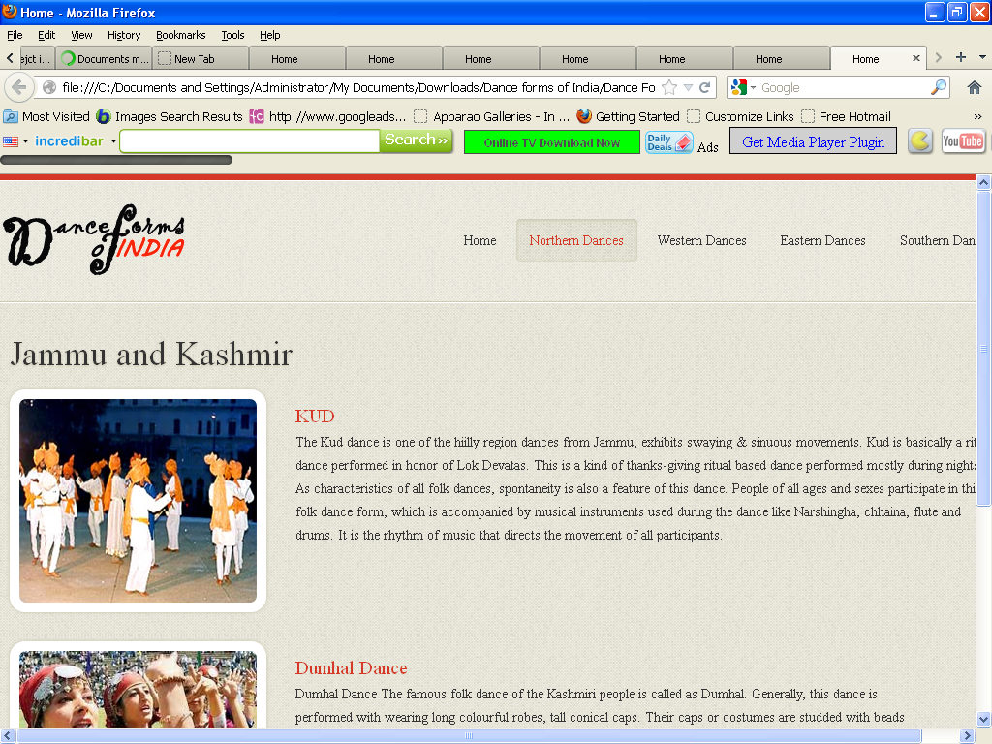

<!DOCTYPE html>

<html lang="en">

<head>

<title>Home</title>

<meta charset="utf-8">

<!--css-->

<link rel="stylesheet" href="css/reset.css" type="text/css" media="screen">

<link rel="stylesheet" href="css/style.css" type="text/css" media="screen">

<link rel="stylesheet" href="css/grid.css" type="text/css" media="screen">

<link rel="icon" href="images/favicon.ico" type="image/x-icon">

<link rel="shortcut icon" href="images/favicon.ico" type="image/x-icon" />

<link rel="stylesheet" href="css/flexslider.css" type="text/css" media="screen">

<!--js-->

<script type="text/javascript" src="js/jquery-1.7.1.min.js" ></script>

<script type="text/javascript" src="js/superfish.js"></script>

<script type="text/javascript" src="js/jquery.flexslider-min.js"></script>

<script>

jQuery(window).load(function () {

jQuery('.flexslider').flexslider({

animation: "fade",

slideshow: true,

slideshowSpeed: 7000,

animationDuration: 600,

prevText: "",

nextText: "",

controlNav: false

})

});

</script>

</head>

<body>

<!--==============================header=================================-->

<header>

<div class="line-top"></div>

<div class="main">

<div class="row-top">

<h1><a href="index.html"><img alt="" src="images/logo.gif"></a></h1>

<nav>

<ul class="sf-menu">

<li ><a href="index.html">Home</a></li>

<li class="active"><a href="#">Northern Dances</a>

<ul>

<li><a href="JnK.html">Jammu n Kashmir</a></li>

<li><a href="HP.html">Himachal Pradesh </a>

<li><a href="Uttarakhand.html">Uttarakhand</a></li>

<li><a href="Haryana.html">Haryana</a></li>

<li><a href="Punjab.html">Punjab </a>

<li><a href="Rajasthan.html">Rajasthan</a></li>

<li><a href="UP.html">Uttar Pradesh</a></li>

<li><a href="Bihar.html">Bihar</a></li>

<li><a href="Jharkhand.html">Jharkhand</a></li>

<li><a href="Chhattisgarh.html">Chhattisgarh</a></li>

<li><a href="MP.html">Madhya Pradesh</a></li>

</ul>

</li>

<li><a href="#">Western Dances</a>

<ul>

<li><a href="Maharashtra.html">Maharashtra</a></li>

<li><a href="Gujarat.html">Gujarat </a>

</ul>

</li>

<li><a href="#">Eastern Dances</a>

<ul>

<li><a href="WB.html">West Bengal</a></li>

<li><a href="Orissa.html">Orissa </a>

<li><a href="Jharkhand.html">Jharkhand</a></li>

<li><a href="AP.html">Arunachal Pradesh</a></li>

<li><a href="Assam.html">Assam </a>

<li><a href="Manipur.html">Manipur</a></li>

<li><a href="Meghalaya.html">Meghalaya</a></li>

<li><a href="Mizoram.html">Mizoram</a></li>

<li><a href="Nagaland.html">Nagaland</a></li>

<li><a href="Sikkim.html">Sikkim</a></li>

<li><a href="Tripura.html">Tripura</a></li>

</ul>

</li>

<li><a href="#">Southern Dances </a>

<ul>

<li><a href="AndP.html">Andhra Pradesh</a></li>

<li><a href="Karnataka.html">Karnataka </a>

<li><a href="Kerala.html">Kerala</a></li>

<li><a href="TN.html">Tamil Nadu</a></li>

</ul>

</nav>

<div class="clear"></div>

</div>

</div>

</header>

<!--==============================content=================================-->

<section id="content"><div class="ic"></div>

<div class="border-horiz"></div>

<div class="container_12">

<article class="grid_8">

<h3>Jammu and Kashmir</h3>

<ul class="list-recipes">

<li>

<figure class="box-img"><img src="images/JK1.jpg " alt="" /></figure>

<div class="overflow">

<h4>KUD</h4>

<p>

The Kud dance is one of the hiilly region dances from Jammu, exhibits swaying & sinuous movements. Kud is basically a ritual dance performed in honor of Lok Devatas. This is a kind of thanks-giving ritual based dance performed mostly during nights. As characteristics of all folk dances, spontaneity is also a feature of this dance. People of all ages and sexes participate in this folk dance form, which is accompanied by musical instruments used during the dance like Narshingha, chhaina, flute and drums. It is the rhythm of music that directs the movement of all participants.

</p>

</div>

<div class="clear"></div>

</li>

<li>

<figure class="box-img "><img src="images/JK2.jpg " alt="" /></figure>

<div class="overflow" style= "width:62%" >

<h4>Dumhal Dance</h4>

<p>

Dumhal Dance The famous folk dance of the Kashmiri people is called as Dumhal. Generally, this dance is performed with wearing long colourful robes, tall conical caps. Their caps or costumes are studded with beads and shells. Only the men folk of the Wattal are privileged to perform this dance on specific occasions.

With dancing, the performers sing beautiful songs in chorus. Drums are used to assist the music in the dance. The vocal singing of the participants is tuned with music. The group of performers moves in a ritual manner and dig a banner into the ground on set occasions. Usually, the dance begins with men dancing around this banner. Dumhal is performed on set occasions and at set locations. </p>

</div>

<div class="clear"></div>

</li>

</ul>

</article>

<div class="clear"></div>

</div>

</section>

<!--==============================footer=================================-->

<footer>

<div class="main">

<center> <p>Some traditions of the Indian classical dance are practiced in the whole Indian subcontinent, including Pakistan and Bangladesh, with which India shares several other cultural traits. Indian mythologies play significant part in dance forms of countries in South East Asia, an example being the performances based on Ramayana in Javanese dances.</p> </center>

</div>

</footer>

</body>

</html>